Sirevåg harbour fact sheet
Position 58°30'14.9"N 5°47'32.5"E
Distances in nautical miles
From Antwerp to Sirevåg: Approx. 460 nautical miles
From Sirevåg to Stavanger: Approx. 48 nautical miles
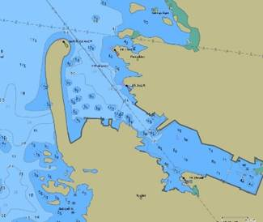
Description of Sirevåg
Every summer, idyllic Sirevåg is a popular destination for sailors and boaters alike. Sirevåg has a very large breakwater protecting its harbour (it is the second largest man-made jetty in Europe) which makes it a safe and good place to dock. To the north are long sandy beaches - Jærstrendene, with beautiful open-air sceneries and wide horizons. During World War II, the Germans built a fortress on the hill Vedafjellet, just south of Sirevåg, as part of ”Festung Norwegen”. Viewpoints and caves in these hills are still intact and are visited by many tourists every year.
Contacts
Project coordinator Anne Marie Gjølme
E-mail AnneMarie.Gjolme@ha.kommune.no, phone +47 90 07 57 46
Harbour master Sven Harbo
E-mail sven.harbo@ha.kommune.no, phone + 47 93 25 93 16
Corporative activities
Sirevåg harbour will organise different types of corporate activities in cooperation with visiting tall ships. If you are interested in hosting deck events, please contact our lead project coordinator.
Crew services and activities
- 20 July: Local market open
- 20 July Tall Ships Races Early Arrivals festival in the harbour
- 20 July Crew party in the afternoon/evening
- German Costal fortress from World War II with viewpoints and caves
- Nice sandy beach for walks and swims
- Hikes in nature
General facilities
- Supply of water and electricity
- Toilets & showers
- Free WiFi
- Small grocery shop and bakery close to the harbour
- Fish & sea food shop & café
- Cafés, bar, hotel
- Sirevåg train station close to the harbour with services to Stavanger and Kristiansand (via Egersund)
- Stavanger airport 6 miles from the harbour
Harbour Conditions
Quay length: 320 metres
Depth (harbour entrance and harbour): 4-9 metres
Quay capability for A, B, C, D classes
Maximum draft/restrictions: Sirevåg harbour is open to the sea to the west. The harbour is therefore exposed to wind, especially from western and northern directions. The port area has good water depths and is easy to navigate.
Tidal Conditions +/- 10cm
Safe/inside harbour anchorage
Free tugs available if necessary. Ships must book pilots in advance through SafeSeaNet Norway

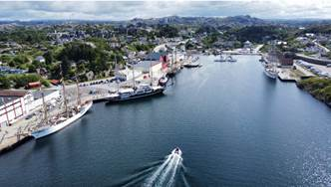 | 
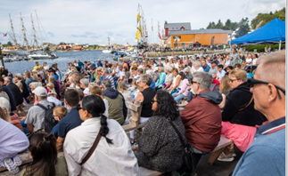 | 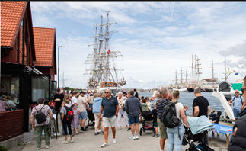
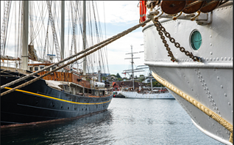 | 
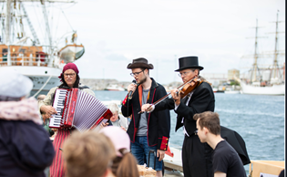 | 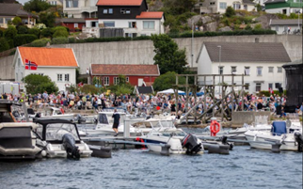
 | 